Business Justification

Rule configured at South Colo Internet Firewall for traffic from WFH user (assigned with one IP address from the VPN Pool) towards internet filtered on specific URL as seen in IInd screenshot.

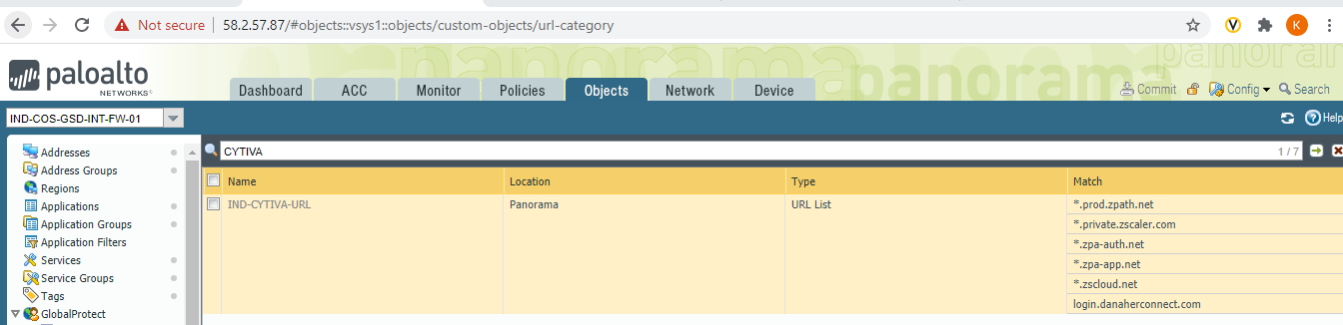

Similar set of configurations have been made at North Colo, Cincinnati & Dallas locations.